Refraction PhET Lab Name ____________________________

Hour ____
Objectives:
- Use ray diagrams to model the refraction of light from air into glass.
- Deduce whether the index of refraction for a material is a constant.
- Verify Snell’s Law and use it to identify an unknown material.

Background: How does light bend?
Light travels at different speeds in different media. As light passes at an angle from one medium to another, it changes direction at the boundary between the two media. The index of refraction of a medium, n, is the ratio of the speed of light in a vacuum, c, to its speed in the substance, v.

n = c/v

When light enters a medium with a higher index of refraction than the medium it is leaving, it bends toward the normal. When light enters a medium with a lower index of refraction than the medium it is leaving, it bends away from the normal. This change of direction of light at the boundary of two media is called refraction.
For any light that is traveling from one medium of index of refraction n₁, at angle of incidence θ₁, to another medium of index of refraction n₂, Snell’s law of refraction describes the angle of refraction, θ₂, experienced by the light.

n₁ sin θ₁ = n₂ sin θ₂

For air, the index of refraction is equal to 1, because the speed of light in air is nearly equal to the speed of light in a vacuum. Whenever air is the medium of incidence of the light, Snell’s law can be simplified.
n₂ = sin θ₁/ sin θ₂

In this lab, you will measure the angle of refraction of light in a glass slab for a number of different angles of incidence. You then will calculate the index of refraction of the glass. Finally, you will compare the index of refraction for each angle of incidence to verify that it is a constant.

Materials:
Chromebook or Computer
PhET Simulation “Bending Light” at https://phet.colorado.edu/en/simulation/bending-light

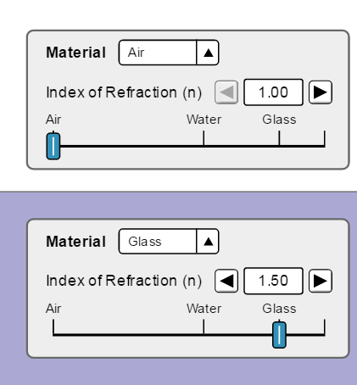
Procedure: Part A Setup
- Open the simulation “Bending Light” at PhET. Use the address above or use Google.
- Click on Intro.
- Leave the default for entry material at “Air”. Choose “Glass” for the exit material (See pic on right). Record the index of refraction of glass into Table 1
- Choose the protractor and set the laser to an angle of incidence, θ₁, at 30°. Recall: angles are always measured from the Normal.
- Ignore the reflected ray (the ray that remains in air). Using the protractor, measure the angle of refraction, θ₂, of the laser and record in Table 1.
- Repeat steps 4 and 5 of this lab for 4 more angles of incidence of your own choosing. Record the results in Table 1.

Data:
Table 1
Trial | nglass | θ₁ (degrees) | θ₂ (degrees) | Sin θ₁ | Sin θ₂ | n₂
1 |  | 30
2

3

4

5

Observations and Calculations:
- Classify the bending of light as exhibited by the ray diagrams. According to your data, is light refracted away from or toward the normal as it passes at an angle into a medium with a higher index of refraction?

- Calculate sin θ₁ and sin θ₂ for each trial. Record the results in Table 1.
- Calculate n₂ for each trial. Record the results in Table 1.

- Compare the values for index of refraction of glass for each trial (values in last column). Is there good agreement between them? Would you conclude that index of refraction is a constant for a given medium?

- Compare your calculated n₂ with the given index of refraction, n_{glass}. Do they agree? Explain why it does or doesn’t.

Procedure: Part B Setup
- Reset simulation and choose “Mystery A” if you are at an even lab station or choose “Mystery B” if you are at an odd lab station.
- Choose the protractor and set the laser to an angle of incidence, θ₁, at 30°.
- Ignore the reflected ray (the ray that remains in air). Using the protractor, measure the angle of refraction, θ₂, of the laser and record in Table 2.
- Repeat steps 2 and 3 for angles of incidences of 50° and 70° of your own choosing. Record the results in Table 2.
- Calculate sin θ₁ and sin θ₂ for each trial. Record the results in Table 2.

Table 2
Trial | θ₁ (degrees) | θ₂ (degrees) | Sin θ₁ | Sin θ₂
1 | 30
2 | 40
3 | 50
4 | 60
5 | 70

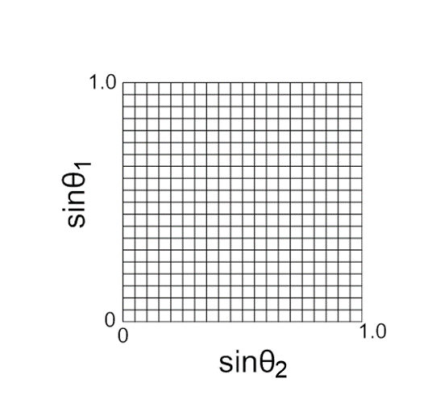
- Draw a graph of the Sin θ₁ vs. Sin θ₂ on the grid below. Draw in your best-fit line and find the slope. Show slope work below.

- What does your slope represent?

- Using the chart below of various indices of refraction for various media, identify your mystery material you had in your experiment.
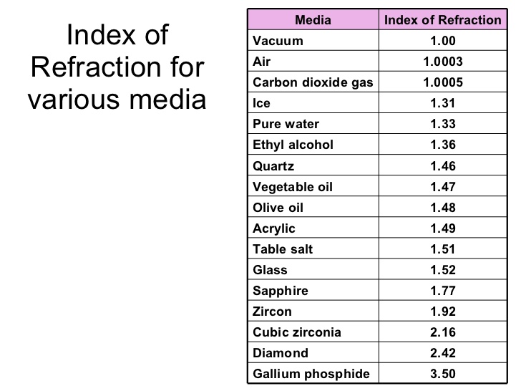
- Find the percent error of your observed value (slope) using the identified index of refraction as your accepted value.
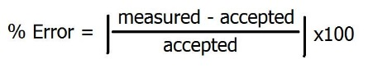

Analysis Questions:

- Substitute the average value of the index of refraction that you measured in Part A into the equation for index of refraction and calculate the speed of light in the glass. Show work.

- What if you conducted this experiment (Part A) under water? Compare and contrast the results you get in such a situation to the results you have from this lab.

